**Entering Data into gitHub**

1. Navigate to gitHub, click the link to the “Lipid_Quantification” repository, then navigate to the “Data” folder.
2. Click the link for the excel file: “Extraction Samples JLM.xlsx”.
3. Download the file using the “Download” button or select “View Raw”.

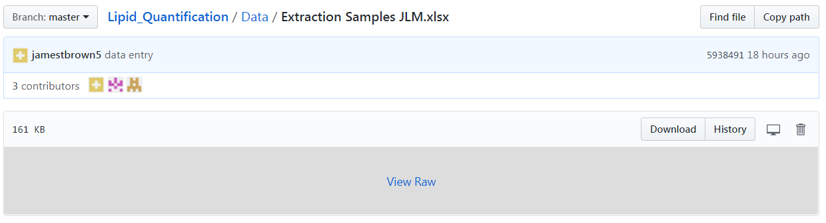

1. Open the computers Download folder.
2. Open the “Extraction Samples JLM.xlsx” spreadsheet.
3. Enter the data then save the file on the computer in the Downloads folder.
4. Return to gitHub.
5. Upload the saved file to the Data folder in the Lipid_Quantification repository.

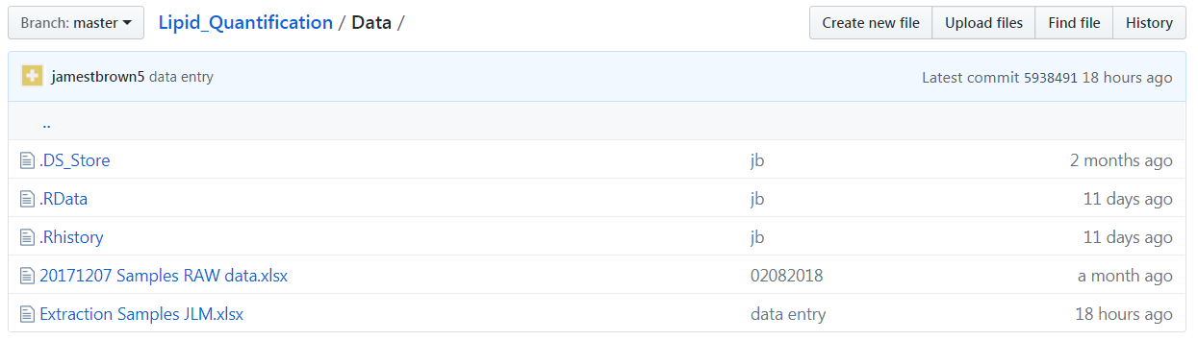

1. Delete the excel file from the computer’s Downloads folder.